SS8G1 SUMMARY: GEORGIA’S GEOGRAPHY

SS8G1a Locate Georgia in relation to region, nation, continent, and hemispheres.

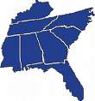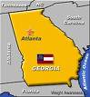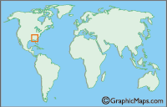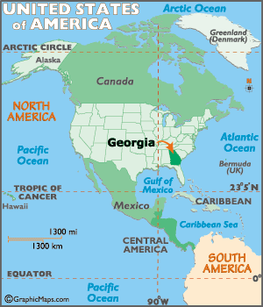

SS8G1b Describe the five geographic regions of Georgia; include the Blue Ridge Mountains, Valley and Ridge, Appalachian Plateau, Piedmont, and Coastal Plain.

APPALACHIAN PLATEAU
•Smallest region in northwest corner of the state
•Source of coal deposits
•Location of Lookout Mountain
Ruby Falls, and Cloudland
Canyon with high elevations
as part of the Appalachian
Mountain range.
•Poor soil for farming
BLUE RIDGE MOUNTAINS
•Northeast corner of the state
•Origin of Georgia’s rivers due to mountains
that cools the warm, moist air from the Gulf
•Brasstown Bald at 4,784 feet above sea level
•Known for marble production, recreational
tourism, hardwood forests, and farming of
vegetables and apples
•Site of beautiful waterfalls such as Amicalola
Falls, Toccoa Falls, and Tallulah Gorge b/c
the region receives the most precipitation

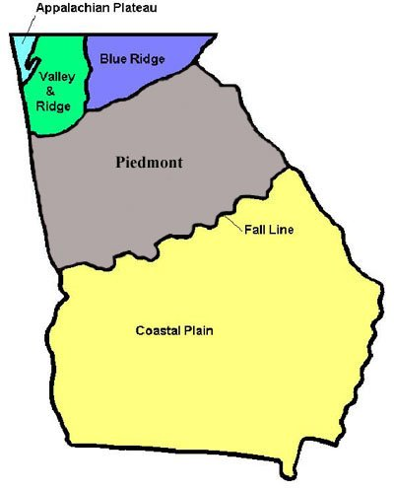
PIEDMONT
•Piedmont means ‘foot of mountain’ and contains rolling hills
•Soil is fertile for farming; crops such as wheat and soybeans. Also famous for Georgia red clay and granite rock such as Stone Mountain
•Contains ½ of the state’s population primarily in the capital city Atlanta as well as Columbus, Macon, and Augusta; plenty of industries and jobs
•Once known as the cotton belt during the pre-civil war history of Georgia

VALLEY and RIDGE
•Located between the
Appalachian Plateau and
Blue Ridge Mountain
Regions and the site of
Several Civil War
battlefields
•Forests and fertile
valleys provide land for
cattle and crops
•Known for textile and
carpet manufacturing
such as the Carpet
capital of the world in
Dalton, Georgia.

COASTAL PLAINS
Bordered by the Fall Line to the north this region of Georgia makes up 3/5ths of the state and was once covered by the Atlantic Ocean. As the major agricultural region this area produces crops such as world famous Vidalia onions, tobacco, peanuts, pecans, and sweet potatoes. This region is home to the Okefenokee Swamp the largest freshwater wetland in Georgia. In addition, there are about 100 miles of flat land bordering the Atlantic Ocean with the barrier islands within site from the coast. Rivers in this region are navigable (good for boats) and help transport goods to cities inland or to the sea port for trade. The land is sparsely populated with small cities and towns.

SS8G1c Locate and evaluate the importance of key physical features on the development of Georgia; include the Fall Line, Okefenokee Swamp, Appalachian Mountains, Chattahoochee and Savannah Rivers, and barrier islands.

APPALACHIAN MOUNTAINS
Oldest mountains in North America and once the home of Cherokee Indians. Site of the 1st gold rush in Dahlonega. The high elevation provides much of Georgia’s rain and source of drinking water. Its beauty attracts tourists during all seasons and the deposits of coal and marble mineral are in abundance.
SAVANNAH RIVER
Forms the boundary between Georgia and South Carolina. The river begins at Lake Hartwell and flows southeast to Savannah before depositing into the Atlantic Ocean. Since colonial times the river is used for travel and trade in the Coastal Plains region. From the Fall Line and further north the river is used for hydroelectric purposes and serves as a source of water for many people.

BARRIER ISLANDS
Islands protect the mainland from storms and waves; attract a lot of tourists due to excellent climate, beautiful resorts, nice beaches, and recreational activities; provide jobs for the fishing industry and paper production.

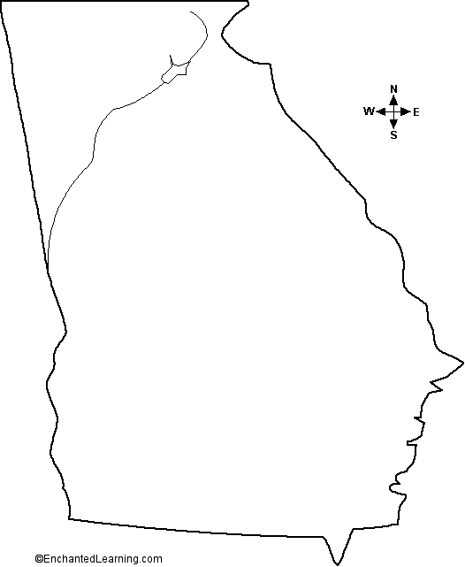
CHATTAHOOCHEE RIVER
Begins in the Blue Ridge Mtns and flows southwest through the city of Atlanta and eventually becomes part of the boundary between Georgia and Alabama. South of the Fall Line the river is used for trade and boat travel. North of the Fall Line the river is used to generate hydroelectric power and is a source of drinking water for many Georgians. In addition, the rive offers many recreational activities for tourists.

SS8G1d Evaluate the impact of climate on Georgia’s development.

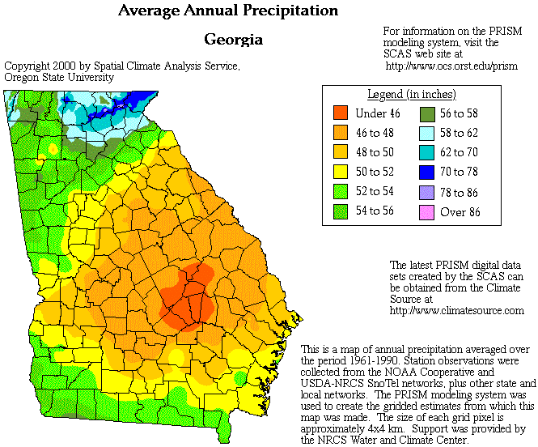
FALL LINE
Natural boundary separating the Piedmont and Coastal Plains regions. Columbus, Macon, and Augusta were built along this line due to the ending of navigable rivers from the south going northbound because of the elevation drop. Because of this there hydroelectric power has been harnessed for industries. The soil is perfect for the growing of peaches and the mineral kaolin is Georgia’s largest natural resource.
AGRICULTURAL DEVELOPMENT
Georgia’s mild climate and rainfall allow farmers to work the land to grow a variety of crops during a longer growing season than farmers in the north. A variety of crops include apples and vegetables in the Blue Ridge region; wheat soybeans, and corn in the Piedmont; to peanuts, pecans, peaches, and onions in the Coastal Plains region. Agriculture also includes raising animals such as cattle in the Valley and Ridge region for dairy farms like Mayfield and the raising of poultry (chickens) in the Piedmont. The impact of climate on agriculture is huge b/c it provides a lot of jobs for Georgia citizens, not just farmers, but transportation, food processors, and stores.

TOURISM DEVELOPMENT
Georgia’s climate varies from the cool mountains in the north to the sunny beaches in the southeast. Tourists from Georgia and abroad flock to different areas of the state for vacation. Some families spend days in the Appalachian Mtns camping, whitewater rafting, or even enjoying the snow falls in Blue Ridge region. Georgia’s climate allows people to visit plenty of local, state, and national parks, even amusement parks like Six Flags and Whitewater. Families can vacation on one of the many barrier islands off the coast of Georgia as there are golf courses, beaches, parks, and resorts. Tourism brings a lot of money to the state, mainly because Georgia has a warm climate.

Georgia has a mild humid subtropical climate. Summers are hot and humid, while winters are cool. Moist air from the Gulf of Mexico provides much of the state’s rainfall. The Atlantic Ocean provides rainfall for the coastal areas and barrier islands.

The northern part of the state is cooler and receives the most precipitation, which explains why the Blue Ridge region gets snow in the winter season due to higher elevation and latitude.

OKEFENOKEE SWAMP
Located in the southeast corner of the state in the Coastal Plains region. It is the largest freshwater wetland (swamp) in North America.
Became a national wildlife refuge in 1937 by President Franklin Roosevelt because loggers were destroying the natural habitat. Today, the swamp is home to over 400 species of animals.

